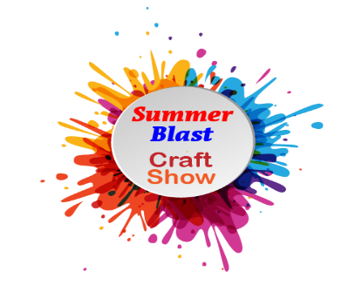
1st ANNUAL SUMMER BLAST CRAFT SHOW
June 15, 2024 10am – 4pm (Rain or Shine)
All Proceeds to benefit Meadville Area Free Clinic
New Artisan—Crafter—Direct Sales Vendor
Agreement for space rental

Company/Organization: __________________________________

Contact Person: ______________________________________Telephone: _______________
Cell Phone:_______________
Mailing Address: _______________________________________

City: _______________________________ State: _________ Zip: _________________

Email: _____________________________________

Emergency Contact: ______________________ Emergency Phone : _______________________

RATE SCHEDULE
10’ x 10’ Outdoor Space $25 $___________

10’ x 20’ Outdoor Space $45 $___________

Additional 10’ x 10’ spaces are $15/space ______ x 15 $___________

Total Due with application $ ____________
DESCRIPTION OF EXHIBIT:
Is it a trailer? __________, Total length ____

Is it a tent/canopy________, If so, which? ____________ Size _________
Any Special Requests:______________________________________________________________________________
Need to Park by Space?(only a few available) ___
List all items to be sold and/or displayed:
_________________________________________________________________________________________________
_________________________________________________________________________________________________
_________________________________________________________________________________________________

Set-up: 7am Saturday Morning Craft Show: 10am – 4pm (Rain or Shine) NO EARLY TEAR DOWNS!!!

WAIVER: I (THE UNDERSIGNED) hereby agree to abide by the terms and conditions set forth on the information sheet(s). I understand that if I fail to comply with the rules of the festival, I may be asked to leave, and that the booth space rental/electric fee is non-refundable. I do not hold the Summer Blast Craft Show committee, Cottage Organics, LLC, the Meadville Area Free Clinic Board, the Meadville Area Free Clinic, the Crawford County Commissioners and/or Crawford County Fairgrounds and its lessees liable for loss, damage, theft or destruction of personal property during the set-up, tear down and operation of the Summer Blast Craft Show..

SIGNATURE _____________________________________________________ DATE ______________________________

Please return this application with your check or money order (made out to Cottage Organics) to:
Cottage Organics, ATTN: Summer Blast, 470 Walnut St., Meadville, PA 16335 or email application to summerblastpa@gmail.com and pay via Venmo to @cottageorganics mark for Summer Blast.
Deadline: MAY 17, 2024

